how to open file in eclipse ?

1.first open eclipse browse create one folder and select it and launch then

2.open perspective->java->open

3.File->new->java Project->project Name->next next finish

4.clicl on Restore->src->remove moduleinfo.java->click on src->new->java class/interface->name file_name

JDBC connection for 11 th program?

Terminal for jdbc

open Terminal

MySQL -u root -p

Enter password:***

mysql>create database databasename

mysql>use database

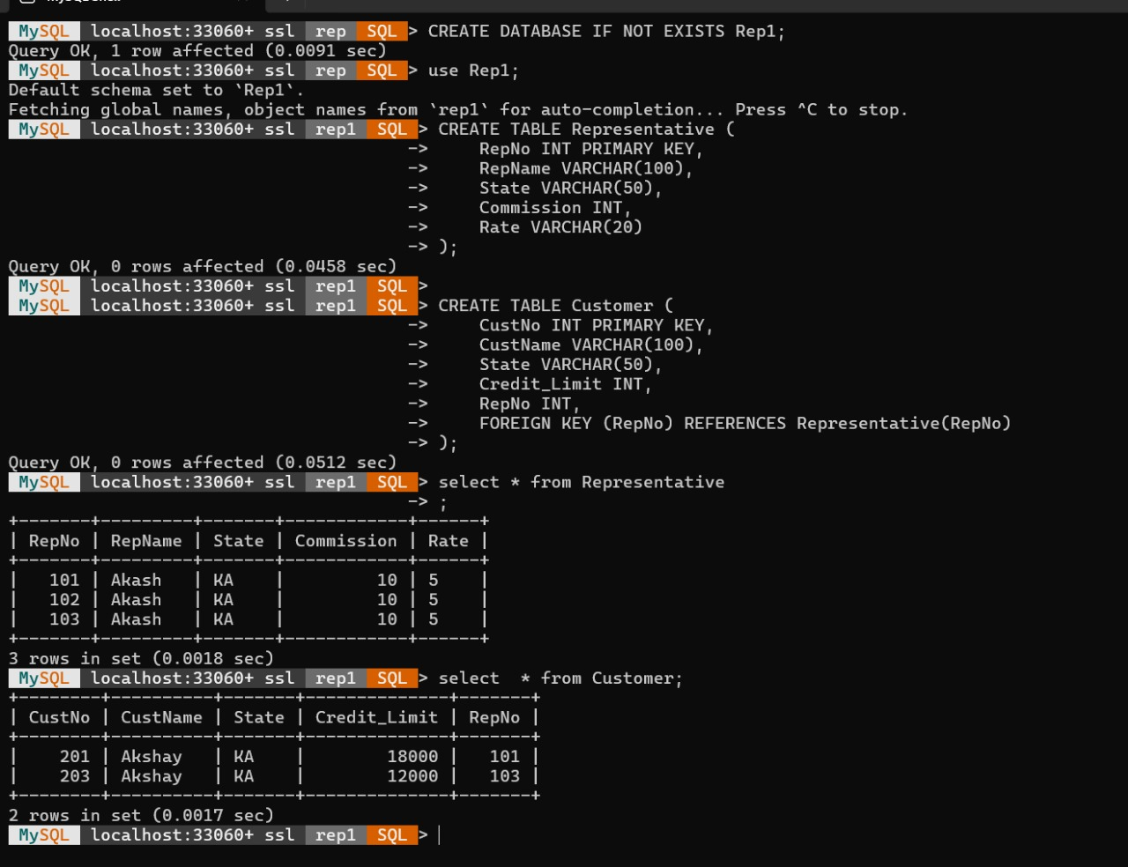

ON THE IDE(Eclipse)

click on the Project->build path->configure module path add external MySQL jar (mysql-connector.jar) and then run the project

Process for 12th Program

open perspective - java ee-> open file-> new dynamic web project-> project name-> webapp mele right click-> new jsp file index.jsp-> code should be written

click on the Project->right click->run as-> run onserver

a dialogue box will appear will two options

1.use the existing sever->apache tomcat v10.0->select this and click ok

2. manually define a new server aapache tomcat v10.0 sever browse and find the folder

localhost

How to run on vs code?

Step 1: Download and Extract Apache Tomcat

Download Apache Tomcat 10.1.41 from the link below:

Link : https://dlcdn.apache.org/tomcat/tomcat-10/v10.1.41/bin/apache-tomcat-10.1.41.tar.gz

Step-2:

Open the extracted tomcat folder in terminal and run the following commands :

Go to /bin and execute this command "sh startup.sh"

~/Downloads/apache-tomcat-10.1 (1).41$ cd bin

~/Downloads/apache-tomcat-10.1 (1).41/bin$ sh startup.sh

Using CATALINA_BASE: /home/ritlab-01/Downloads/apache-tomcat-10.1 (1).41

Using CATALINA_HOME: /home/ritlab-01/Downloads/apache-tomcat-10.1 (1).41

Using CATALINA_TMPDIR: /home/ritlab-01/Downloads/apache-tomcat-10.1 (1).41/temp

Using JRE_HOME: /usr

Using CLASSPATH: /home/ritlab-01/Downloads/apache-tomcat-10.1 (1).41/bin/bootstrap.jar:/home/ritlab-01/Downloads/apache-tomcat-10.1 (1).41/bin/tomcat-juli.jar

Using CATALINA_OPTS:

Tomcat started.

Create a folder (in this case : "testfolder")

~/Downloads/apache-tomcat-10.1 (1).41/bin$ mkdir testfolder

~/Downloads/apache-tomcat-10.1 (1).41/bin$ cd testfolder/

create a folder "WEB-INF"

~/Downloads/apache-tomcat-10.1 (1).41/bin/testfolder$ mkdir WEB-INF

~/Downloads/apache-tomcat-10.1 (1).41/bin/testfolder$ cd ..

Step -3 :

create the index.jsp file with all the required code in the folder u created (in this case, 'testfolder')

Step- 4:

in terminal to run the testfolder, run this comand :

firefox localhost:8080/testfolder